**Lista de Exercícios Inner join – Lab. BD prof. Ms Larissa Pavarini da Luz**

Nome:_____________________________________________________________RA:________

Resolva os exercícios das duas formas: usando o comando Where e inner join

Problem List

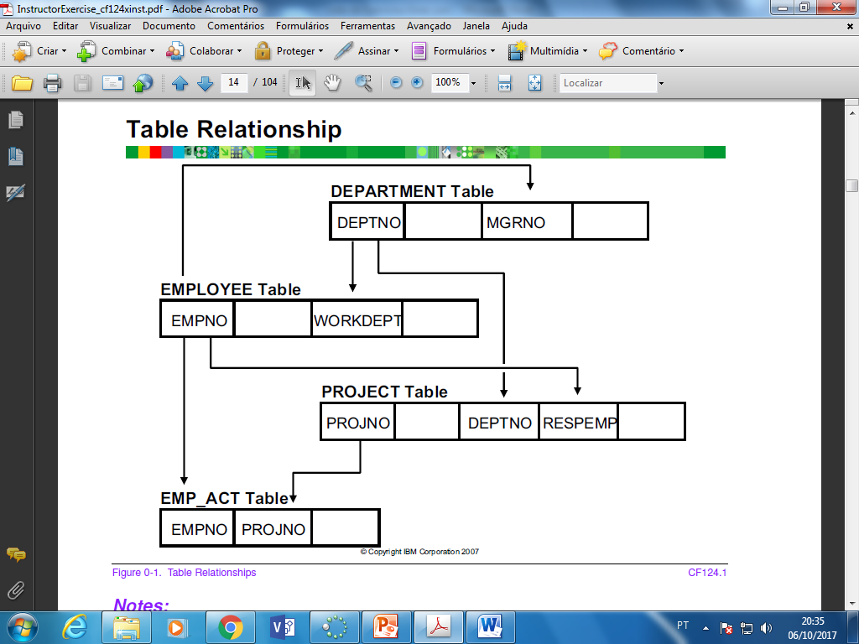

Problem 1

Produce a report that lists employees' last names, first names, and department names. Sequence the report on first name within last name, within department name.

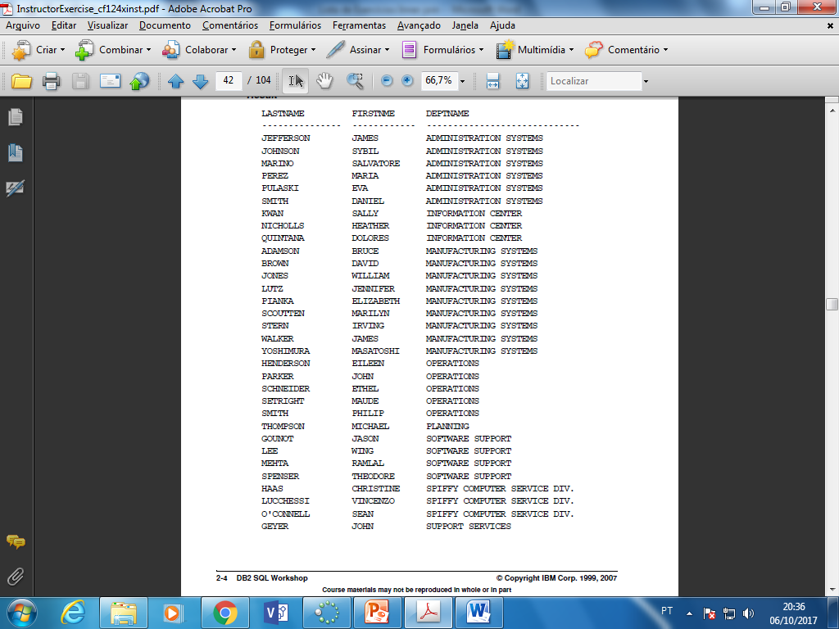

Problem 2

Modify the previous query to include job. Also, list data for only departments between A02 and D22, and exclude managers from the list. Sequence the report on first name within last name, within job, within department name.

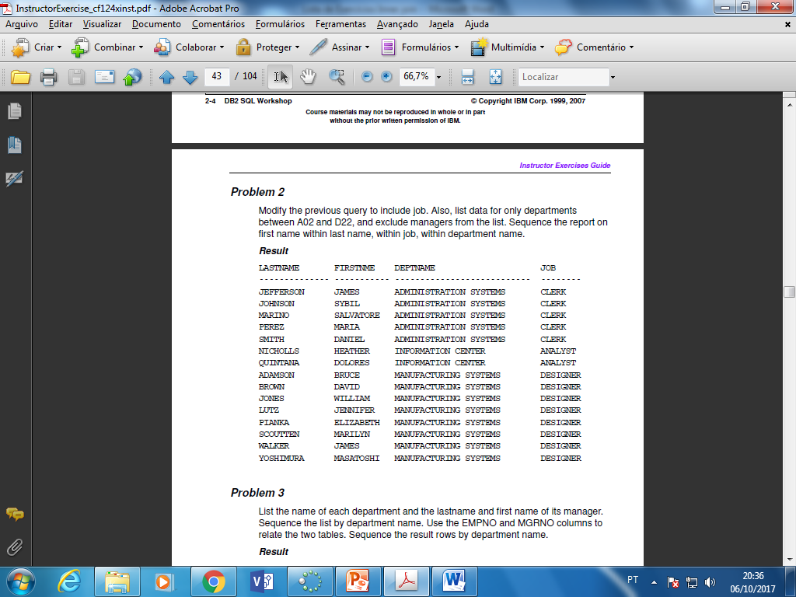

Problem 3

List the name of each department and the lastname and first name of its manager. Sequence the list by department name. Use the EMPNO and MGRNO columns to relate the two tables. Sequence the result rows by department name.

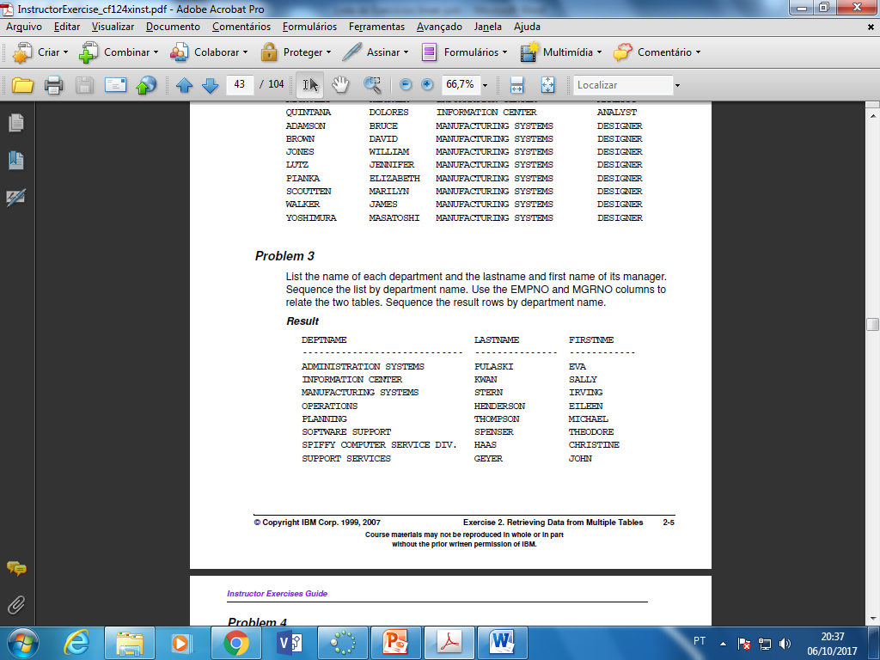

Problem 4

Try the following: modify the previous query using WORKDEPT and DEPTNO as the join predicate. Include a local predicate that looks for people whose job is manager.

Are the results from both queries the same?

__________________

Why?

_____________________________________________________________________________________________________________________________________________________________________________________________________

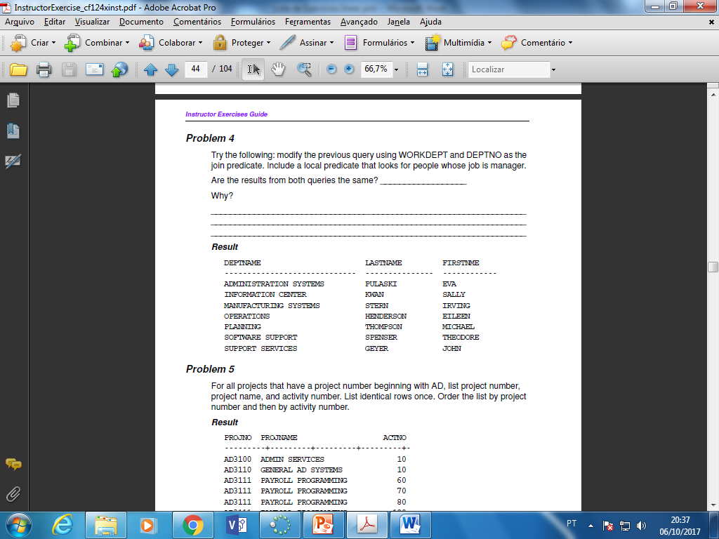

Problem 5

For all projects that have a project number beginning with AD, list project number, project name, and activity number. List identical rows once. Order the list by project number and then by activity number.

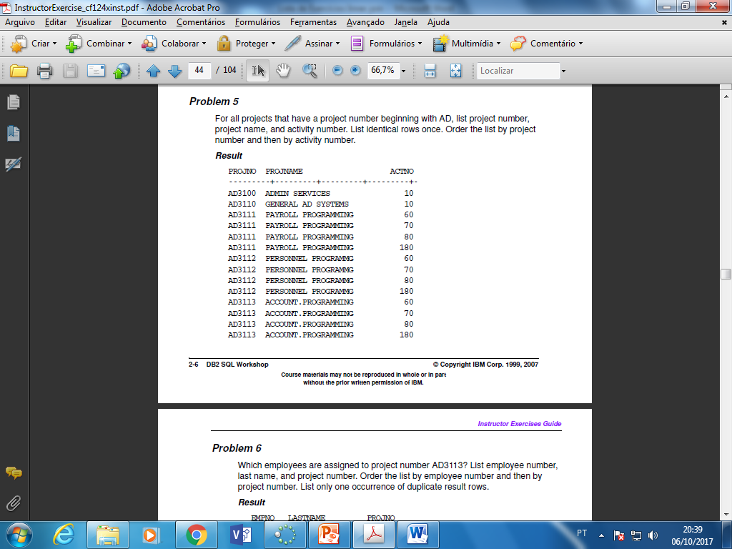

Problem 6

Which employees are assigned to project number AD3113? List employee number, last name, and project number. Order the list by employee number and then by project number. List only one occurrence of duplicate result rows.

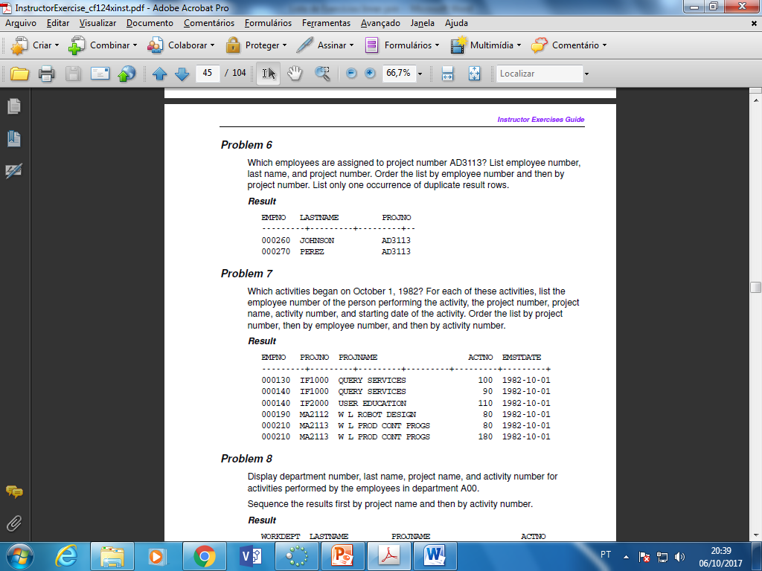

Problem 7

Which activities began on October 1, 1982? For each of these activities, list the employee number of the person performing the activity, the project number, project name, activity number, and starting date of the activity. Order the list by project number, then by employee number, and then by activity number.



Problem 8

Display department number, last name, project name, and activity number for activities performed by the employees in department A00.

Sequence the results first by project name and then by activity number.

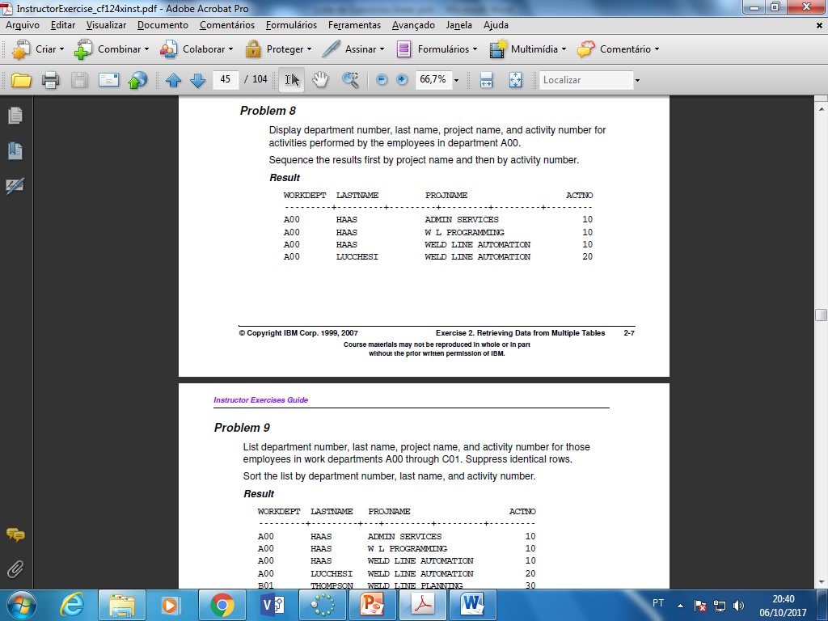

Problem 9

List department number, last name, project name, and activity number for those employees in work departments A00 through C01. Suppress identical rows.

Sort the list by department number, last name, and activity number.

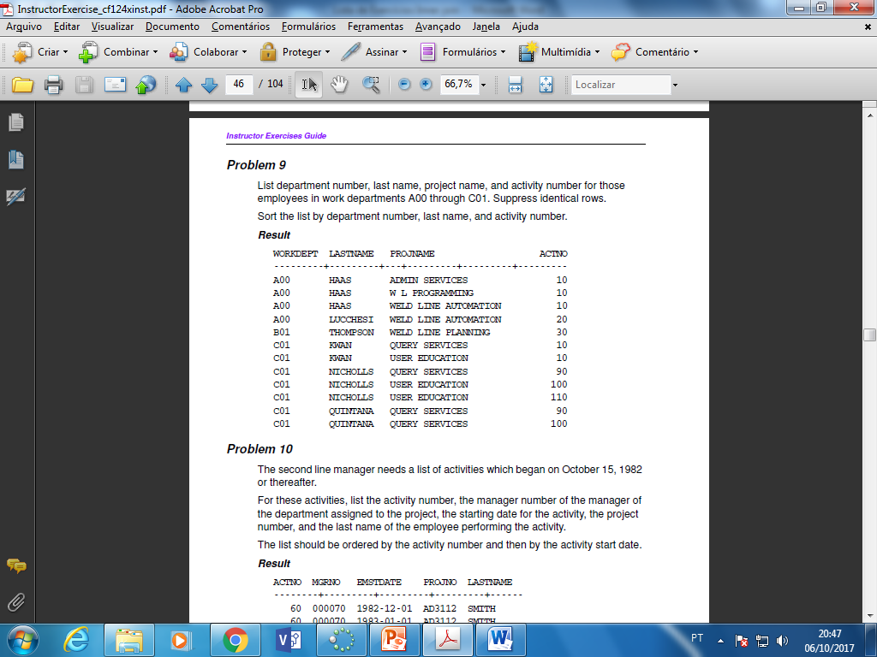

Problem 10

The second line manager needs a list of activities which began on October 15, 1982 or thereafter.

For these activities, list the activity number, the manager number of the manager of the department assigned to the project, the starting date for the activity, the project number, and the last name of the employee performing the activity.

The list should be ordered by the activity number and then by the activity start date.

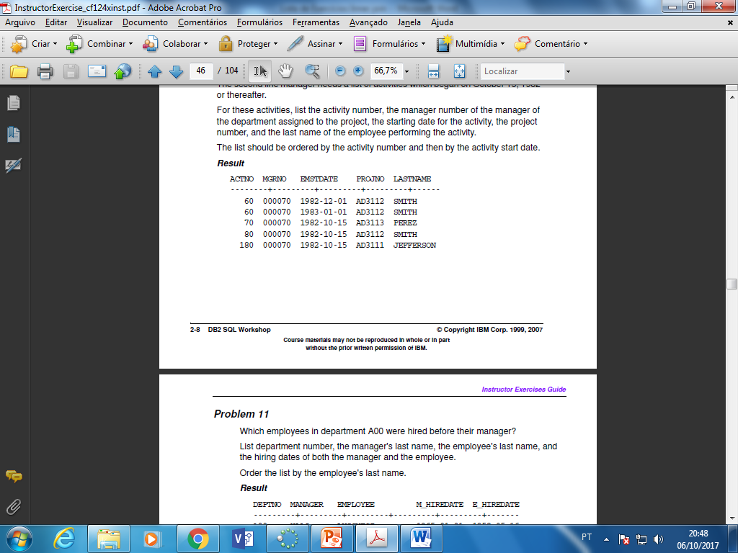

Problem 11

Which employees in department A00 were hired before their manager?

List department number, the manager's last name, the employee's last name, and the hiring dates of both the manager and the employee.

Order the list by the employee's last name.

